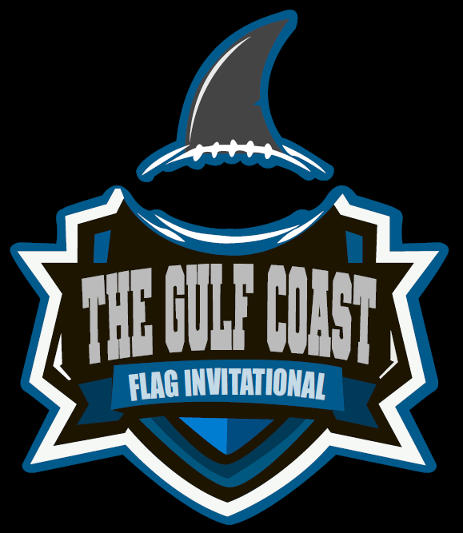
2021 Gulf Coast Youth Flag Football 5 on 5 Invitational All-Star Tournament Informational Packet
Eastern Shore Flag Football is proud to host the inaugural 2021 Gulf Coast Youth Flag Football Invitational All Star Tournament. Tournament information can be found below, and any questions or additional information may be found by contacting Bo White (251) 463-7315 or Rodger Fike (205)515-3811 or by email at contact@easternshoreflag.com
Tournament Dates and Location:
- December 11th & 12th, 2021
- Trione Park Football Fields, 8600 Whispering Pines Rd, Daphne, AL 36526
Registration:
- Deadline for registration is December 3rd , 2021
- Maximum of 16 teams per age division
- Birth Certificate for each player
  - Player can play in age group of the players age on January 1st of 2021. Example player is 10 January 1st and turns 11 January 5th player can play in 10U age group.
Registration Fee:
- $250.00 team registration fee
  - This includes the $150.00 tournament fee and the $100.00 gate fee
- Checks can be made out to Eastern Shore Flag Football and may be mailed to PO Box 1543 Daphne AL 36526 or turned Friday night at registration & coaches meeting.
- A full refund will be issued if a team prepays and can not make the tournament.
- If a division does not receive enough teams to host a tournament, registered teams in that division will be notified by 12/4/21 and all registration fees will be refunded in full.

Coaches Meeting:
- The coaches meeting will be held on Friday December 10th at 6:30 pm for all age groups.
  - 1410 US HWY 90 Suite O Daphne, AL 36526
- This is a mandatory meeting for all teams or program. At least one coach from each team or program representative will be required to participate in the coaches meeting.
- All registration fees and birth certificates for each player will be required at the meeting.
Tournament Details
- Format: *4 game guarantee. *This is a two day tournament where all teams will be playing both days. Teams will compete in a 3 game round robin (Saturday Morning/Early Afternoon) followed up with a single elimination playoff bracket (Sunday Morning or Afternoon). Round Robin play will determine bracket seeding. If a division is made of a team or teams from out of state, the single elimination games will be played on Sunday morning so out of state teams can travel back home.
Facilities:
- We will be playing at the Trione Park Football Fields, 8600 Whispering Pines Rd, Daphne, AL 36526
- Concessions and restrooms are located at the complex
- Water will NOT be provided
- Coolers are allowed
- Absolutely NO SMOKING or electronic cigarettes are allowed in the complexes
- Tents are allowed.
Rosters:
- Each team shall have a maximum of 10 players on their roster
- Please see our league website for more information on hotels and updates
General Rules and Regulations:
- Rules can be found at Travel Flag (easternshoreflag.com)
  - These rules are NFL youth flag football rules with a few exceptions, please see rules packet for the rules exceptions.
- Verification: All Players need to provide verification information (birth certificate and headshot) prior to or end of registration deadline. NON-VERIFIED players will not be allowed to play. (Should a coach decide to play a non-verified player the game will be considered a forfeit and a loss in team’s record) ESFF will also consider if team can continue in the tournament.
- PLAYER BEHAVIOR:
  - Players may chant or shout positive things to their teammates. Negative or unsportsmanlike comments directed to opposing players, coaches, or fellow teammates will not be tolerated and could lead to team forfeit/loss and player disqualified from tournament.
- SPECTATOR BEHAVIOR:
  - Spectators should act in a sportsmanlike manner. Anyone attending the game is subject to the alcohol rules of the league and violation of this rule will be cause for immediate removal from the park area. Please promote a positive environment for the players of this tournament. Any spectator in violation of this policy may be asked to leave the field area. Spectators participating in any negative or unsportsmanlike behavior comments directed to opposing players, coaches, or fellow teammates will not be tolerated and could lead to team forfeit/loss, Spectator removal from tournament area and player associated with Spectator disqualified from tournament.
ESFF reserves the right to determine unsportsmanlike conduct.

